|  |  |
| --- | --- |
|  |  |

**Faculty of Technology and Engineering**

**Chandubhai S. Patel Institute of Technology (CSPIT)**

**Department of Computer Science & Engineering**

Date: / /

**Laboratory Manual**

|  |  |  |  |  |  |
| --- | --- | --- | --- | --- | --- |
| Academic Year | : | 2024-25 | Semester | : | 4 |
| Course code | : | CSE206 | Course name | : | DATABASE MANAGEMENT SYSTEM |

|  |
| --- |
| **Practical - 1** |
| **Aim: Global Trust Bank is expanding its operations and requires a robust database management system to efficiently manage its employees, job profiles, customers' accounts, and loan information. The bank has laid out specific requirements and constraints to ensure data integrity, uniqueness, and completeness.**  **Requirements**  **Employee Management:**   * Job Profiles: Maintain records of different job profiles. * Employees: Store detailed information about employees, including their association with job profiles.   **Customer Management:**   * Accounts: Maintain separate records for customers' bank accounts. * Loans: Maintain separate records for customers' loan details * Design and implement the schema as per the given information.   **Constraints –**   * Not Null Constraints: Critical fields must not be null to ensure data completeness. * Unique Constraints: Certain fields must have unique values to avoid duplicates (e.g., Account Number). * Check Constraints: Enforce domain integrity by limiting the values that can be placed in a column. |

1. Create Table Job (job_id, job_title, min_sal, max_sal)

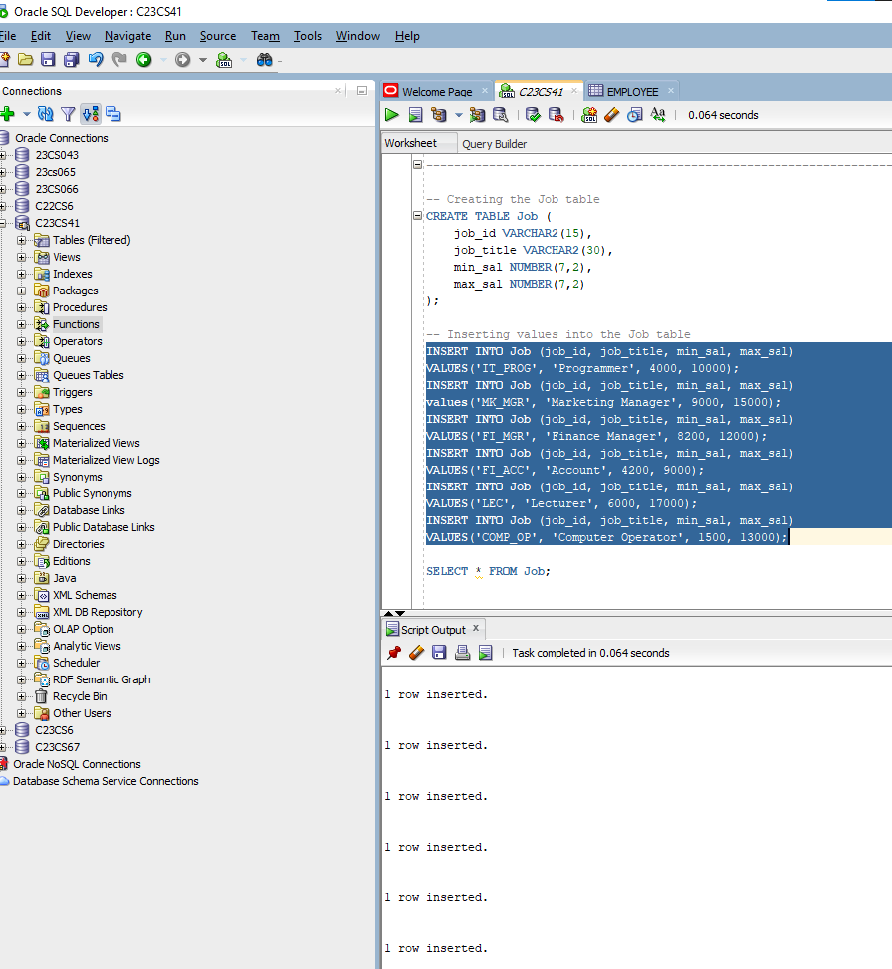

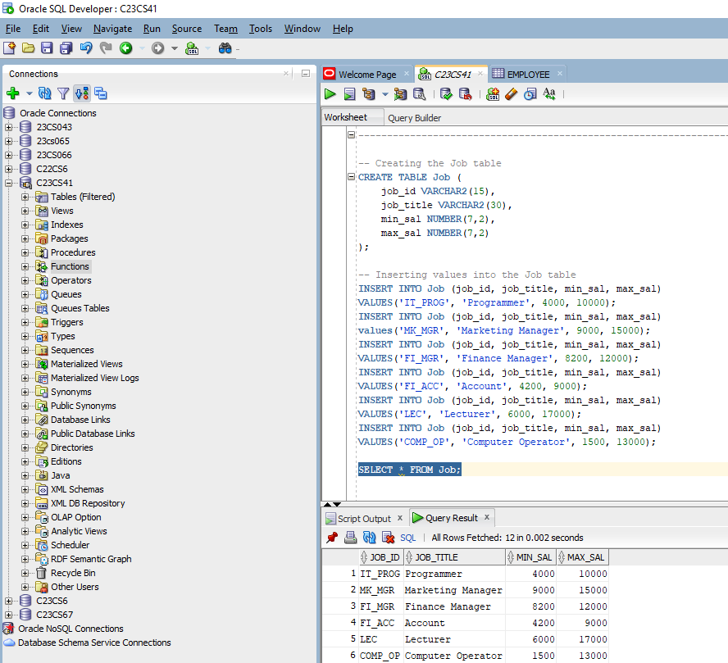

|  |
| --- |
| 1. Create Table Employee (emp_no, emp_name, emp_sal, emp_comm, dept_no) |

1. Create Table Deposit (a_no, cname, bname, amount, a_date)

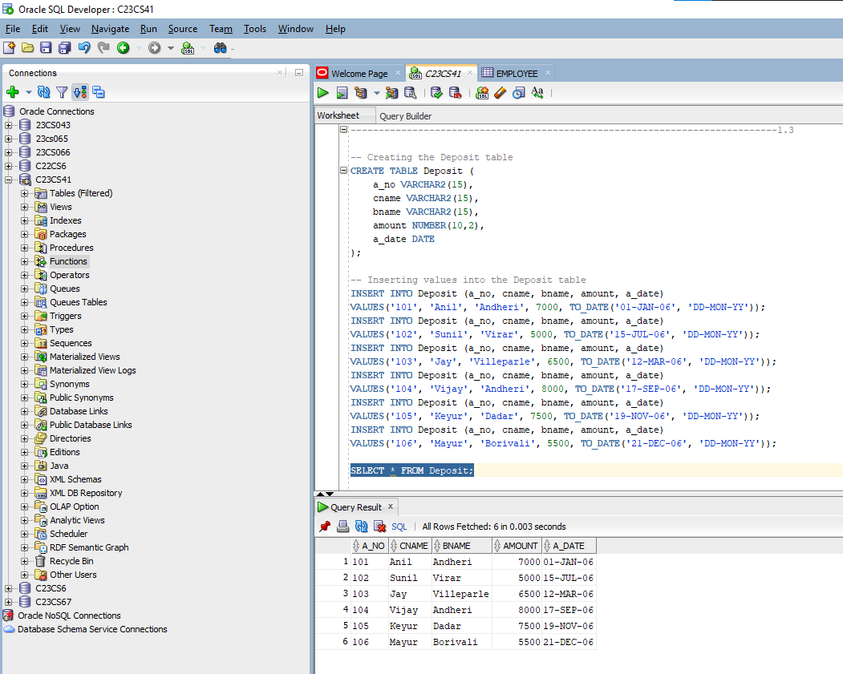

1. Create Table Borrow (loanno, cname, bname, amount)

